Art of Problem Solving:

Decomposition: Solving a Problem from top-down

Stepwise Refinement: Balance testing while decomposing

Example of decomposition: In order to make pasta, you would have to:

1. Make the dough: make_dough()
2. Shape the dough: shape_dough()
3. Cook pasta: cook_pasta()

We can decompose each task even further.

Example:

make_dough():

1. First add flour
   1. How much flour – 300 grams.
   2. while flour <= 300:
      1. flour++
2. Next add eggs
   1. How many eggs – 3.
   2. for i in range(3):
      1. crack egg
      2. split egg
      3. add egg
3. Mix all together

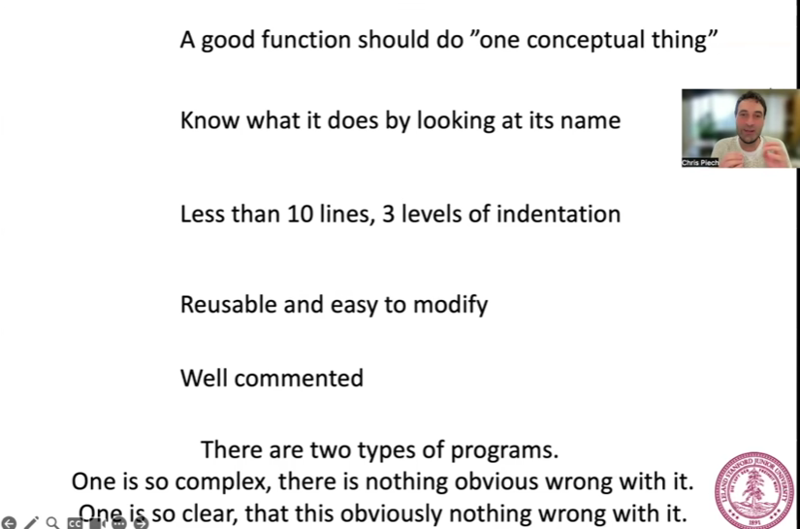

Common errors to avoid:

1. Infinite loops.
2. Avoid pre and post conditions that do not match.